**SCHOOL MISSION STATEMENT**

|  |  |
| --- | --- |
| **Policy version control sheet** | |
| **Date of Policy** | **July 2023** |
| **Next Review Date** | **July 2026** |
| **Reviewed & Edited by** | **Sara Garth** |
| **Approved by** | **Caroline Rolfe** |
| **Policy Location** | **Education server network**  **\\3dsrv1\_Education\Education Local Policies**  **Copy on website** |
| **Links to other policies** | **See all education policies** |

|  |  |  |
| --- | --- | --- |
| **CONTENTS** | |  |
| **Number** | **Contents Details** | **Page** |
| **1** | **Our Intent (and the 4 Be’s)** | **4** |
| **2** | **Our Ethos** | **6** |
| **4** | **Our Aims** | **7** |

**3 Dimensions School is a specialist education provider, situated in Wadeford, Near Chard in Somerset.**

**OUR INTENT**

At 3 Dimensions School, we are fully committed to delivering a holistic and individualised curriculum that is full of rich experiences for all. We want our pupils to be happy and feel a sense of belonging. We get to know each and every one of our pupils, supporting them in the best way that meet their individual needs. We provide a tailored program of education that considers their interests, and is designed to engage and inspire them. Our aim is for our pupils to acquire the skills and knowledge for resilience and success. We wish for our pupils to be friendly to others, and have the ability to build and establish positive relationships. Ultimately, we strive for our pupils to access life, work and independence and be armed with the necessary tools to be successful in school and in their future, in whatever way they choose.

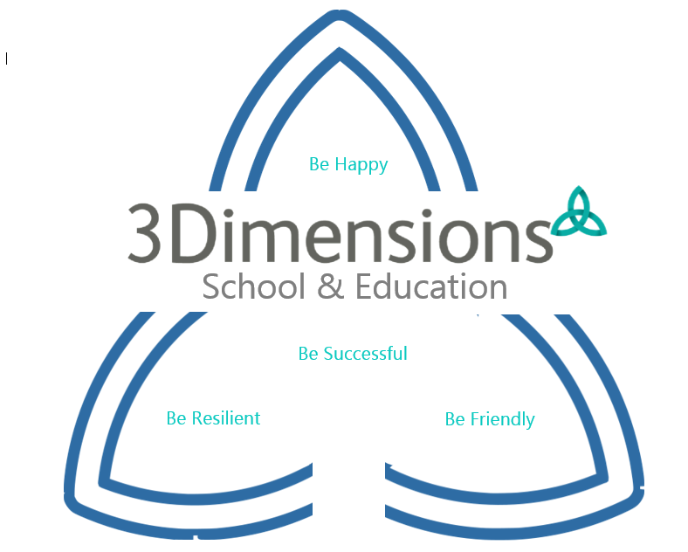

1. **Be happy** – It is important that our pupils are happy, feel that they are valued and have a sense of belonging. We strive to give our pupils opportunities to have their own voice and feel that they have the power to make a positive difference in their own lives, and to the lives of others.
2. **Be resilient** – many of our pupils have poor self-esteem and self-worth and have had disrupted and often negative experiences in previous school settings, therefore, we aim to support each pupil to become confident in their abilities, and to ask for help assuredly when they need it. We want our pupils to be emotionally resilient and to be able to regulate their emotions with increasing independence. We aim for our pupils to leave 3 Dimensions school with a good understanding of their emotions, how to get support when they need it, and to manage their emotions positively. 3 Dimensions school want our pupils to engage positively with learning and be motivated to achieve the best personal outcomes for themselves.
3. **Be friendly** –We strive to give our pupils a wide range of opportunities, underpinned by the fundamental British values, including democracy, the rule of law and individual liberty. The pupils are encouraged and supported to build positive relationships in all areas of their school life at 3Dimensions. They are encouraged to show an understanding of, and have respect for other people’s viewpoints, recognising that people can have differing views, but still be respectful, and empathetic. These skills ensure that our pupils can develop and maintain strong positive relationships throughout their lives. We aim to support our pupils in developing their social skills and ability that allows them to access their community and be a part of society.
4. **Be successful** – We see each pupil as an individual at 3 Dimensions school, and as such, understand and celebrate that each learning journey will look different. When pupils start at 3 Dimensions School, we take the time to learn about them through a ‘positive pairing’ program. This program enables us to understand what motivates each pupil, and how we can support them to thrive and succeed. We want to ensure that all pupils develop holistically in all areas of their lives. We aim for pupils to gain and develop detailed skills and knowledge, both academically and holistically, building on their personal development skills.

**OUR ETHOS**

3 Dimensions School provides a holistic environment where we can learn, show compassion, and accomplish together. We strive to create opportunities through education, in a positive environment, that is happy, supportive, and constantly improves the lives of children, young adults and the lives of their families.

We recognise, and wholeheartedly believe, that the pupil’s welfare and positive experience in the school environment, is absolutely crucial to his/her development.

* We deliver a highly personalised curriculum that is accessible to all children, and is exciting, diverse, and fulfilling.
* Staff recognise the importance of individuality and encourage our children to embrace this.
* Opportunities are consistently and strongly developed, to help us to instill confidence and independent thinking in all children.
* We create a safe, stable, welcoming, and stimulating environment where individuals are happy and have a positive attitude.
* Mutual respect and values enable us to build strong and worthwhile relationships.
* As a school we celebrate all cultural and religious backgrounds.
* Our school is an inclusive environment where families, school staff and other professionals can work proactively together for the benefit of the children.

**OUR AIMS**

We aim to provide quality outcomes for our students. This can be achieved through the following aims:

* Fostering a happy, secure learning environment where all of our students' needs are met, where recognition and praise is given for all progress and achievement.
* Provide students with the tools to positively manage their behaviors and difficulties
* Ensure our students can be secure, confident, and well-motivated, by promoting their emotional, physical, and spiritual well-being.
* Allow our students to lead as full, interesting, and independent lives as possible, by providing them with the skills, confidence, and knowledge they require.
* Encouraging decision making and help develop the personal responsibility of students, communicating through whatever means appropriate.
* Deliver a wide range of personalised appropriate learning experiences, which provide excitement and challenges.
* Developing their ability to be flexible and adapt to change.
* Provide all students with not only life experiences of their own, but also a recognition of the religious, cultural backgrounds and values, of others**.**
* Make the pupils voice the priority and respect their contributions.
* Develop friendships and respect for others, through opportunities for co- operative working.
* Cultivate and strengthen positive relationships with parents and all other professionals.
* Ensure that all the statutory curriculum guidance is delivered to all pupils/students.
* Constantly develop our staff with training and progressions opportunities to enable effective practice.
* Encouraging them to explore how they think and how they behave through a variety of therapeutic interventions, SALT, OT, person centered approaches and art and Lego therapy.