relationshipS & SEX Education (RSE) Policy

Policy version control sheet

Date of Policy | November 2025
Next Review Date | November 2026
Approved by | Caroline Rolfe  Ciaran Walsh
Policy Location | Education server network  Copy on website
Links to other policies | See all education policies

CONTENTS

Number | Contents Details | Page
1 | RSE Definition | 4
2 | Our Aims | 4
3 | Curriculum and Statutory Requirements | 5
4 | Organisation of RSE | 6
5 | Assessment & Evaluation | 8
6 | Parental right to withdraw from sex education within RSE | 8
7 | Specific Issues | 9
8 | Monitoring Arrangements | 10
9 | Related Policies | 10
10 | Training | 10
 | Appendix 1: Kapow | 11
 | Appendix 2: Asdan | 12
 | Appendix 3: Students knowledge of RSE by end Primary & Secondary school | 14
 | Appendix 4: Parental withdrawal form (from sex education within RSE) | 16

Definition of Relationships & Sex Education

Relationship & Sex Education is lifelong learning about physical, sexual, moral, and emotional development. It is about the understanding of the importance of stable and loving relationships, respect, love, and care, for family life. It involves acquiring information, developing skills, and forming positive beliefs, values and attitudes. It is also about the teaching of sex, sexuality, and sexual health.

Our Aims

The opening paragraph of the Department for Education guidance states:
“Today’s children and young people are growing up in an increasingly complex world and living their lives seamlessly on and offline. This presents many positive and exciting opportunities, but also challenges and risks. In this environment, children and young people need to know how to be safe and healthy, and how to manage their academic, personal and social lives in a positive way.”
(DfE, 2019, Relationships Education, Relationships and Sex Education and Health Education)

We at 3 Dimensions School feel that learning about relationships and sex should:

- Be an integral part of the lifelong learning process.
- Be an entitlement for all young people, regardless of; gender; ability; culture; faith; sexuality or family background.
- Enable young people to acquire accurate information, develop skills and develop positive values that will guide their decision making, judgements, relationships and behaviour throughout their lives.
- Prepare young people for adult life.
- Be provided within a holistic context of emotional and social development.
- Be set within the wider school context and support family commitment and love, respect and affection, knowledge and openness. Family is a broad concept and includes a variety of types of family structure and acceptance of different approaches.
- Enable students and teachers to share and respect each other’s views.
- Raise awareness and an acceptance of the full diversity of relationships and sexual orientation, without promoting any particular family or relationship structure.
- Create an atmosphere where questions and discussion on sexual matters can take place without any stigma or embarrassment.
- Recognise that parents take a key role in teaching their children about sex and relationships and growing up. We aim to work in partnership with parents.
- Recognise the wider community has much to offer and we aim to work in partnership with health professionals, social workers, peer educators and other mentors or advisers.

Curriculum and Statutory Requirements

From September 2020, Relationships and Health Education are compulsory in all primary schools in England.
This DfE guidance clearly states the statutory requirements, i.e. what children MUST be taught by the end of primary school. Health Education includes learning about ‘the changing adolescent body’ to equip children to understand and cope with puberty.
The National Curriculum for Science (also a compulsory subject), includes learning the correct names for the main external body parts, learning about the human body as it grows from birth to old age and reproduction in some plants and animals. (which could include human beings).
So, Relationships Education, Health Education and Science are compulsory subjects and parents/carers do NOT have the right to withdraw their children from these subjects.
It is up to schools to determine what is meant by ‘Sex Education’. At primary school age, it is usually agreed to mean ‘human reproduction’ and can be taught within Science.
If, however, it is taught within PSHE/RSHE parents have the right to request their child is withdrawn from these specific lessons.
The DfE recommends, ‘that all schools should have a Sex Education programme tailored to the age and the physical and emotional maturity of the pupils.’ The school will share its position on teaching Sex Education with parents/carers through its policy, and if relevant will make clear which lessons they can request their child is withdrawn from, i.e. which lessons constitute this additional Sex Education, if any.
Relationship & Sex Education at 3 Dimensions School is delivered via the following routes:

- Our RSE curriculum is set out within this policy in Appendix 1 and 2. We review our curriculum and programmes regularly and adapt provision when appropriate and necessary.

- Our RSE curriculum provision is always tailored to the needs, ages, abilities and emotional wellbeing of our students.

- Parents and guardians of our students are informed of our RSE curriculum provision and invited to consult with teaching staff regarding any area of concern or to further learn about our approach.

- RSE that falls under National Curriculum Science is included within science lessons at both Chardleigh and Hummingbird and ensures the teaching of key areas such as main external body parts and development, the human body as it grows from birth to old age and the biological aspects of reproduction (including puberty) in some plants and animals. These are taught as part of science in accordance with National Curriculum for the appropriate key stage.

- We adhere to the statutory RSE government guidance (see link below), including paragraphs 33-35: pupils with SEND, paragraphs 36-37: pupils understanding of LGBT, and paragraphs 54–82: RSE primary and RSE secondary delivery, to inform our delivery of RSE. Our approach is a bespoke one, utilising resources from several sources, rather than a single program of delivery. For early years and primary level students we utilise Kapow Primary for PSHE and RSE. For secondary level students we use Cre8tive for PSHE and RSE.https://assets.publishing.service.gov.uk/government/uploads/system/uploads/attachment_data/file/1090195/Relationships_Education_RSE_and_Health_Education.pdf

Organisation of Relationships & Sex Education at 3 Dimensions School

3 Dimensions School is a special needs school that meets the needs of young people aged 7 – 25, who can have social needs; communication difficulties, learning disabilities, sensory difficulties and ASD.

Relationship and Sex Education is taught throughout the school from early years, to primary and secondary level. We utilise the Kapow Primary program for PSHE and RSE, which targets learners from early years, and primary Year 1 – Year 6. . We use the Cre8tive programme for PSHE and RSE for secondary age pupils. Our approach is individualised to the needs of each student, and the course content is tailor made to suit that child and ensure they can access the learning in accordance with their age and development. RSE is taught in small groups, pairs, or on a one to one basis, as appropriate. All staff involved in teaching RSE have developed good relationships with students and have a sound understanding of their needs. A safe learning environment is established for each student to enable open and non-judgemental discussions about sex, sexuality, and sexual health. Staff use a wide variety of methods to encourage young people to participate in their learning, for example, through discussion, ICT, storytelling, social stories, role play, matching and sequencing. Annex B of the government RSE and Health education guidance (as per section 2) has suggested resources teaching staff may use, such as NSPCC PANTS. Where appropriate, we draw from other resources such as; Jigsaw programme, Twinkl, and NHS Leeds Puberty and Sexuality documents.

Due to the vulnerable nature of our students, it is important we have an honest approach to all areas of RSE. The teaching materials use are often literal and based on real life to allow students to understand and see exactly what is being discussed. It is vitally important that our students have the correct language and understanding to keep themselves and others safe.

At 3 Dimensions school we celebrate diversity and foster an inclusive culture and environment. Complex issues regarding gender identity, gender expression and sexual orientation can create difficulties and challenges for young people that cause them to experience distress, bullying, discrimination and result in negative unhealthy outcomes. Students at 3 Dimensions are taught to treat others with dignity and respect, regardless of differences. Teaching is delivered in a sensitive manner, when appropriate, to ensure students have an increased awareness of the diverse world we live in, to understand inclusive vocabulary and terminology, and lead happy, healthy and confident lives.

To ensure we challenge myths, misconceptions, and false assumptions about what is perceived to be normal sexual behaviour, when appropriate, students are taught about pornography, female genital mutilation, sensory sensitivities and sex, masturbation and different types of sexuality, identity and behaviours. In a world where access to sexual material is easily available on-line, it is vital our students are given tools to develop perspective on what they see and be empowered to make their own informed choices. All teaching occurs in a sensitive and appropriate manner. All subject matter is taught to ensure students have the correct information and not to promote sexual activity or orientation.

Assessment and Evaluation

Rates of student progress in RSE related learning will be assessed as part of PSHE and Science related progression and through individual personal development. RSE is managed in accordance with the school’s guidance for assessment, recording and reporting.

Parental right to withdraw from sex education within RSE

The Relationships Education, Relationships and Sex Education and Health Education (England) Regulations 2019, come into force on 1st September 2020.

These regulations specify the need to teach Relationships and Health Education as compulsory subjects and the Department for Education strongly recommends this should also include age-appropriate Sex Education. Schools also have statutory responsibilities to safeguard their pupils (Keeping Children Safe in Education, DfE, 2019) and to uphold the Equality Act (2010).

The legal requirements mean that:

All primary schools in England teach relationships education.

All secondary schools teach relationships and sex education.

Reformed statutory guidance for schools is in place, following consultation.

The right of parents to withdraw their children from sex education has been retained. Children approaching age 16 have new rights to ‘opt-in’.

Schools can remain flexible in their approach. This includes faith schools being allowed to teach within the tenets of their faith.

Parents have the right to withdraw their children from sex education within RSE. However, this right is limited; children cannot be withdrawn from aspects of RSE which are part of the National Curriculum for Science. Parents are able to withdraw their children from all or part of sex education within Relationships and Sex Education. Parents should contact the school if they are concerned about any aspect of our provision or wish to discuss key areas of vulnerability regarding their child. Parents are notified of forthcoming RSE lessons and are given the opportunity to contact the school and speak to their child’s teacher.

The above changes apply to all schools in England: local authority-maintained schools, academies and independent schools.

Alternative work will be provided to students who are withdrawn from all or aspects of sex education within RSE.

Please contact the school and talk to your child’s teacher, the head of school, or the teacher in charge of PSHE, if you have any questions about RSE. Often, when parents and carers find out what is in the curriculum, their fears are allayed as they can appreciate it is in the best interests of their child’s lifelong learning and safeguarding.

Please see Appendix 4, page 16, for the parent withdrawal form.

Specific Issues

Child and Sexual Abuse Procedure
- Suspected abuse of any kind should be reported to the Designated Safeguarding Lead. The procedure laid out in the Safeguarding Policy will be followed meticulously.
Confidentiality
- Confidentiality must not prevent action if a child could be ‘at risk’. Teachers will listen sympathetically to anything a young person tells them in confidence. However, if a teacher or member of staff feels a child or young person is at risk then the appropriate people will be contacted in accordance with Child Protection procedures, a copy of which is available upon request. Members of staff are advised to remind students that not all information given to them can remain confidential. All staff will be clear about safeguarding issues and procedures as part of their on-going training. A copy of the Confidentiality Policy is available upon request.

Bullying Procedure
- All students’ views will be treated sensitively. Some attitudes should be challenged, e.g., homophobic bullying, in line with school’s anti bullying policy
Contraceptive Advice
- Specific individual contraception advice should not be given by members of staff. For specific advice on contraception and other aspects of sexual behaviour, students should be encouraged to seek advice from parents or guardians and where appropriate from a healthcare professional.
Equal Opportunities
- Equal opportunities at 3 Dimensions School means that all students, regardless of ethnicity, sexuality and ability have, potentially, all areas open to them.
Professional Development of Staff
- Training will be provided to members of staff who feel unsure about delivering any aspects of the curriculum. This can address the knowledge base, skills and attitudes of members of staff. Training may be given ‘in-house’ or by other suitably qualified professionals.

Monitoring Arrangements

Quality assurance is conducted regularly and via a range of processes i.e. learning walks, book scrutiny, staff and student discussion, and pupil progress.

Pupils’ development in RSE is monitored by teachers internally.

The Head of School and Governors have responsibility for reviewing and monitoring this policy.

Related Policies

- Confidentiality Policy
- PSHE Policy
- Safeguarding Policy
- Inclusion Policy
- Anti-bullying Policy
- Equal Opportunities Policy
- Internet and Online safety Policy

Training

All staff are trained on the requirements and delivery of RSE via OFG’s online training platform Shine.
Where appropriate and relevant, 3 Dimensions Head of School utilises external training providers and invites visitors and professionals, such as sexual health professionals and school nurses, to provide support and further training to staff.

Appendix 1


Primary RSE Approach
Kapow Program
Early Years: The following units of lessons, via our Kapow program, alongside teacher guidance, are provided to develop students RSE and PSHE skills during their early years
Unit 1 | Self-regulation: My feelings
Unit 2 | Building relationships: Special relationships
Unit 3 | Managing Self: Taking on Challenges
Unit 4 | Self-regulation: Listening and following instructions
Unit 5 | Building relationships: My family and friends
Unit 6 | Managing self: My wellbeing

Primary RSE Approach
Kapow Program
KS1 – Years 1 & 2: Students learn about families and relationships, physical health and mental wellbeing, being safe online and first aid and safety.
Lower KS2 – Years 3 & 4: Students will learn about families and relationships, their physical health and mental wellbeing. The issue of influence and choice is explored and an understanding of online safety is further developed. Students also learn basic first aid and are introduced to puberty.
Upper KS2 – Years 5 & 6: Students will further develop understanding of families and relationships, learning about stereotyping and conflict resolution. They will learn to take greater responsibility for their physical and mental health and about puberty, including menstruation and about contraception. Additionally, responsible digital citizenships is further explored.
Unit 1 | Introduction: Setting ground rules for RSE & PSHE
Unit 2 | Family and relationships
Unit 3 | Health and wellbeing
Unit 4 | Safety and the changing body
Unit 5 | Citizenship
Unit 6 | Economic wellbeing
Unit 7 | Transition lesson

Appendix 2

RSE within the Cre8tive curriculum.
Year 7 – Friendships, Respect and Relationships
This unit looks at consent and boundaries and evaluates why personal space and boundaries are important when growing up. It then looks at the wide range of relationships that young people have and the qualities of good friendships. The unit then finishes looking at how to manage these relationships and looks at pressures and influences within different types of relationships.
Year 8 – Identity, Relationships and Sex Education
This unit starts with an introduction to RSE looking at what makes a healthy relationship. It deals with conflict that can happen within relationships. Students will look at the difference between sex and gender and the harmful prejudices and stereotypes that can be associated with these. All students learn about the menstrual cycle. The unit finishes with a brief look at what is love and an introduction to the concept of contraception.
Year 9 – Sex the Law and Consent
Year 9 starts looking at the law concerning sexual consent and FGM. It then looks at delaying sexual activity and the pressures that can be associated with this. It covers the positive and negative reasons to have sex and explores the consequences of making a relationship sexual. Then to finish students, debate the sexualisation of the media and the impact this is having on teens.
Year 9 - Contraception and STIs
In the second half term of RSE Year 9 study STIs in detail. They then look at different forms of contraception looking at how they work and the pros and cons of each type. The realities of contraception and the link between pregnancy and STIs are also studied. The laws and legal frameworks linked to sexual harassment and stalking are explored and knowing the difference between flirting and sexual harassment. The unit finishes looking at HIV and AIDS in more detail.
Year 10 – Exploring Relationships and Sex Education
This looks at the legal, emotional and social consequences of sending sexts. This is then explored further with pornography looking at what is and is not legal and identifying the differences between what is seen in pornography and real life. It explores how common access to pornographic material can affect attitudes and beliefs towards sex, relationships and self. Sexual violence is covered looking at assault and rape. The unit progresses onto pleasure and looks at masturbation and the risk associated with different sexual activities.
Year 11 – Sexual Health
Year 11s study the importance of their sexual health and the impact bad choices can have. They revisit contraception and STIs in further detail. They look at respect in relationships and the importance of this. They then look at fertility and what can impact fertility, leading on to different types of fertility treatment.

Further information about Kapow PSHE, or Cre8tive programs
You are always welcome to contact 3 Dimensions School on 01460 65611 or email education@3dimensions.org.uk . Please also visit the following websites to learn more about their programs and approaches:
Primary Provision:
Kapow Primary PSHE: www.kapowprimary.com/subjects/rse-pshe/
Secondary Provision:

Cre8tive PSHE: Cre8tive Resources - Complete PSHE Secondary Curriculum Package – New

Appendix 3

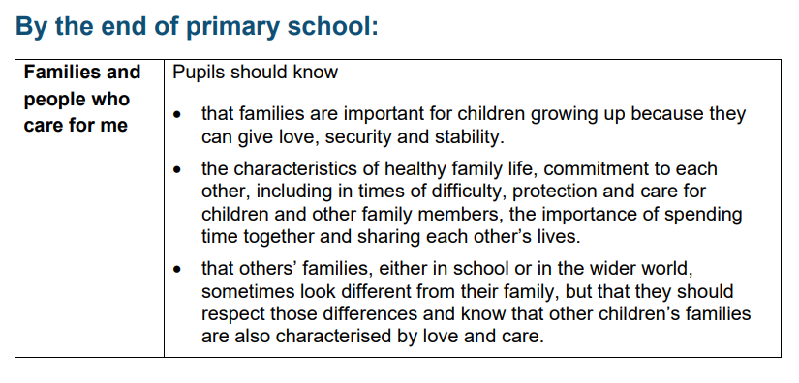
Student knowledge by end of Primary School
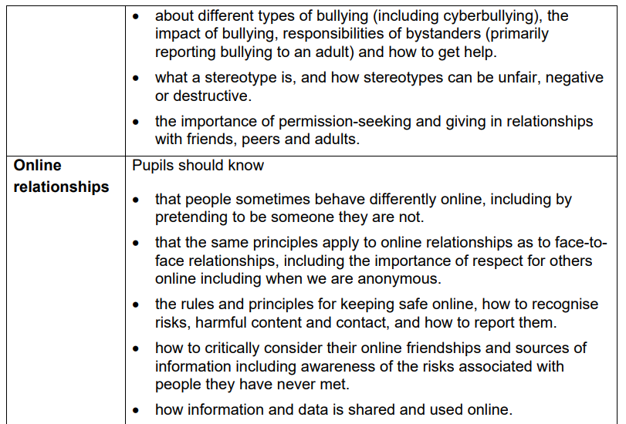

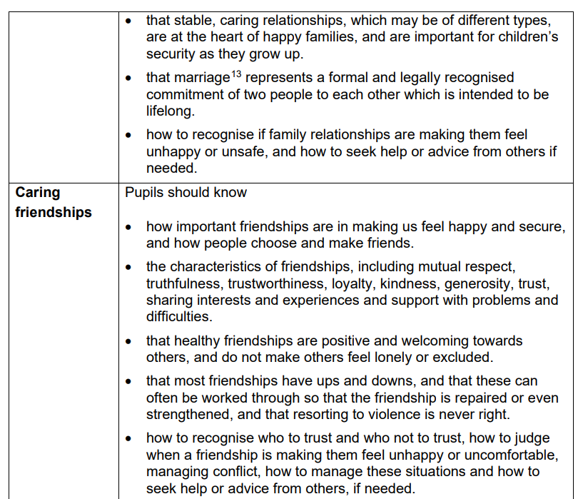

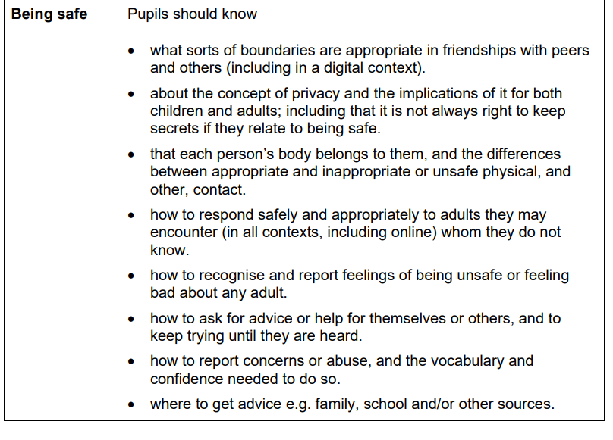
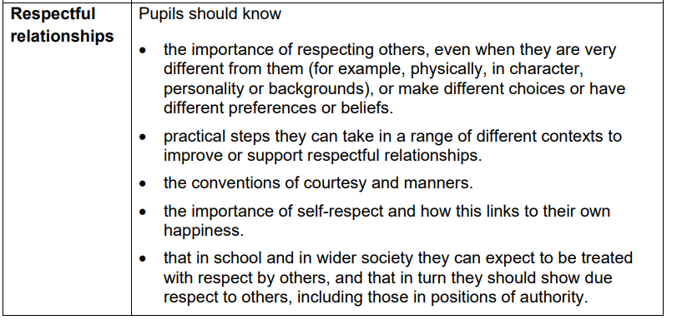

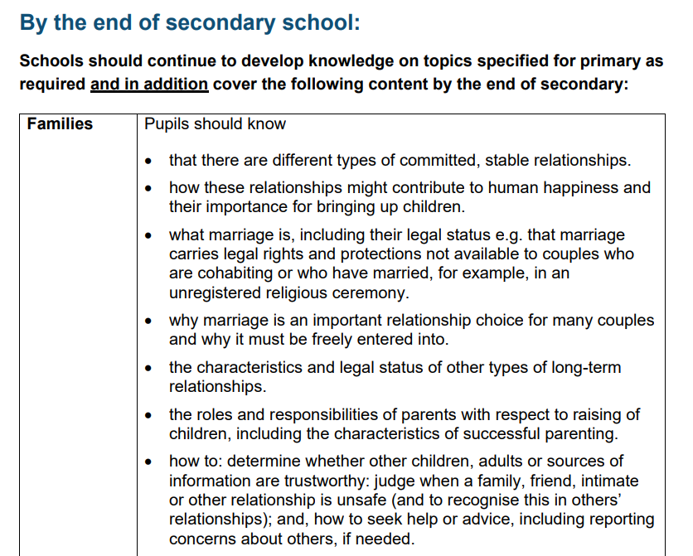
Student knowledge by end of Secondary School

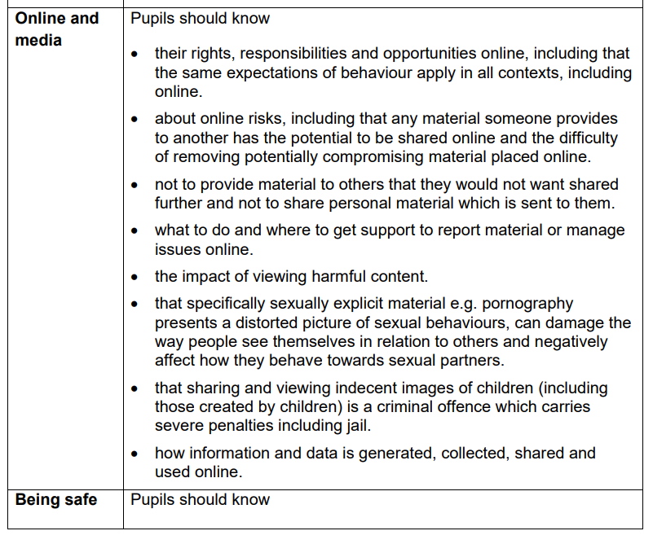
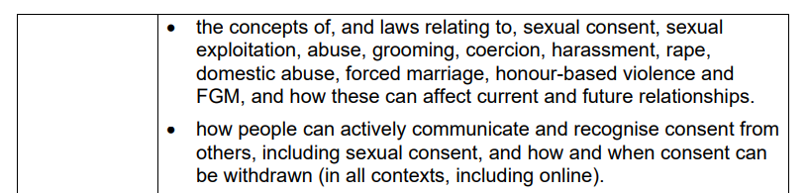

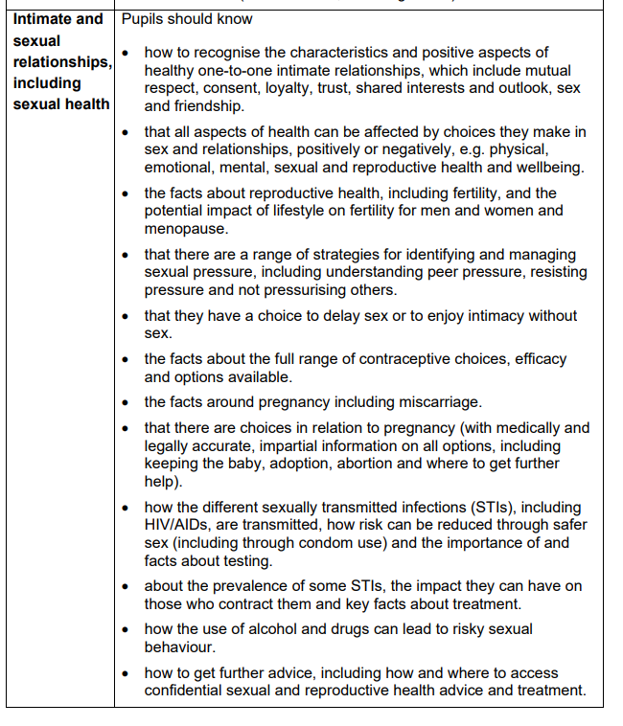

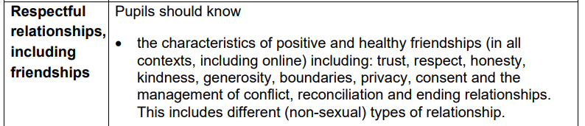

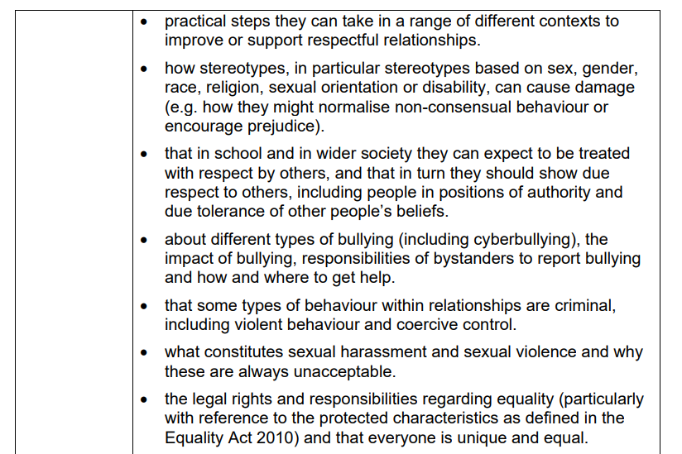

Appendix 4

Parental Withdrawal Request Form
__________________________________________________________________________________
Parental Withdrawal Request Form
If you wish to ‘opt out’ of all, or aspect(s) of sex education, within RSE, please contact school. Additionally, please complete the form below, providing information about your reasons:
Full name of student:

Full name of Parent / Guardian / Carer:

Reason(s) given for withdrawal from sex education within relationships and sex education

Other information you would like 3 Dimensions School to consider
Date:
Parent / Guardian / Carer Signature:

